Fixing 120 Series Toilet Partition Hardware Leg to the Floor
Installation Instructions

120_200SS, 120ALUM-Series, DESIGNER_120ALUM

Using an Allen Key, release the grub screw from the leg (Image 1).

By completing step 1, this will release the floor grommet (Image 2).

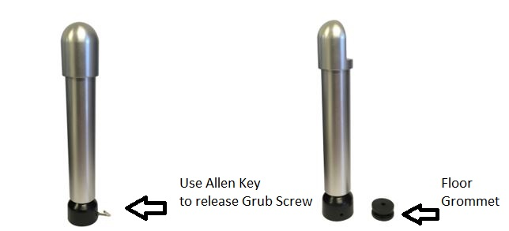

Image 1. Image 2

Fix grommet to the floor using screw provided.

Return leg assembly to the base (floor grommet).

Lock in Grub Screw using Allen Key for secure fixing.

